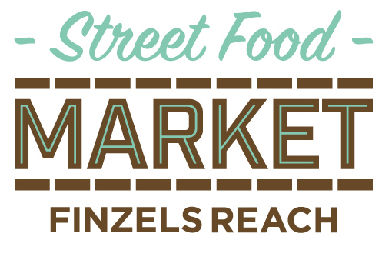

Finzels Reach Market User Guide during COVID-19
Our lovely street food market returns on Friday 5th June but in light of COVID-19, there will be some changes.

Please note that this will include a scaled down version of the market with less stalls so that social distancing measures can be implemented. A queuing system similar to those at the supermarket and a 1-way system in and out of the market will be put in place and we ask that our customers adhere to these simple guidelines which are designed to ensure that the market remains to be safe place to shop. Please take heed of the following:
- A queuing system will be put in place with regulated entry into the market. Stalls will be spaced out with queuing lanes for each trader. If we’re busy, we’ll manage the queue as best we can with social distancing in place.
- You’ll be asked to come, wait for your food and then leave. Service will be swift so please don’t stay any longer than you need to.
- All communal seating will be out of bounds so please don’t stay in the market to eat your food. We suggest going to Castle Park opposite Finzels Reach to enjoy your street food where there is plenty of space.
- You’ll be asked to stand 2 metres apart from each other. Floor markings will help you to do so.
- Please do not come to the market in groups, only people who live in the same household will be able to queue together.
- Traders will offer pre-ordering and contactless payment where possible.
- A hand sanitising station will be provided at the market.
- Traders will continue to follow the FSA guidance on good hygiene practices in food preparation and their HACCP processes. Traders will wear facemasks and gloves.
- Market hours have been extended from 11am – 3pm to avoid crowding
- It is very unlikely that you can catch coronavirus from food. For further government guidance for consumers, please see here: https://www.gov.uk/government/publications/guidance-for-consumers-on-coronavirus-covid-19-and-food
Please be patient while shopping at the market; we’re trying our hardest and are still learning about the best format for a COVID-secure environment.
We look forward to seeing you soon!

